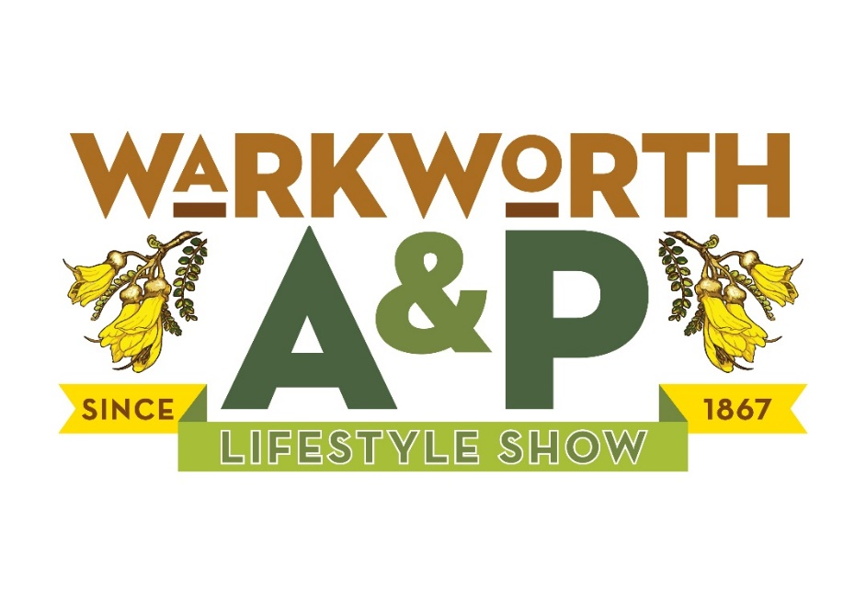
DAIRY GOATS – 2021
SPONSORED BY GULL MATAKANA

Judge: Herbie Blackmore
Steward: Royce and Stephanie Broome

Start time 10.00 a.m.
Entry Fee $6.00 per class
Prize Money: 1st $15.00 2nd $10.00 3rd $5.00 unless otherwise stated.
Enter on line availability - https://showday.online or www.warkworthshow.co.nz
Contact – secretary@warkworthshow.co.nz
or phone 422-2052
Rules & Conditions
- All goats must be penned by 9.30 am.
- All goats must be tied in designated areas.
- Does in milk will NOT be penalised if it is necessary to ease the udder before judging.
- Does may not be stripped out in the ring.
- All goats must be registered and recorded with the NZDGBA at the time of entry and the registration number must be recorded on the entry form.
- The by-laws of The Royal Agricultural Society of NZ for the exhibition of dairy goats shall apply at this show.
- A ten-dollar petrol voucher will be provided to each exhibitor. Sponsored by Gull Matakana
Herd Register Standard Age Classes - Does

Class 241 Kidded Doe in milk - 2 years & under
Class 242 Kidded Doe in milk - 3 & 4 years old
Class 243 Kidded Doe in milk - 5 years & over

Champion Herd Register Doe
To be judged from placegetters in classes 241-243
2nd placegetters to stand by.
Reserve Champion Herd Register Doe

Class 244 Herd Register Grand Champion Age Class
Open to Does which have gained their GCH prefix or are pending the award of GCH.

Herd Register Champion Challenge Doe
The winner of Class 244 to be paraded with the Champion Doe to select the winner of the Champion Challenge Award.
No award will be made if there is no competition in this class.

Associated Records Standard Age Classes - Does
Crossbred, appendix and recorded
Class 245 Kidded Doe in milk - 2 years & under
Class 246 Kidded Doe in milk - 3 & 4 years old
Class 247 Kidded Doe in milk - 5 years and over

Champion Associated Record Doe
To be judged from classes 245-247
2nd placegetters on standby.
Reserve Champion Associated Record Doe

Class 248 Associated Record Grand Champion Class
Open to all Does that have gained their GCH prefix or are pending the award.

Associated Record Champion Challenge Doe
Winner of class 248 to be paraded with the Champion Doe. No award will be made if there is no competition in this class.

Special Classes
All animals entered in this section must have been exhibited in their standard age class
Class 249 Senior Progeny
Two daughters in milk, of the same sire but different dams.
Name of sire and dams must be given on the entry form.
Class 250 Dam & Daughter
Class 251 Sire & Progeny - 2 progeny, at least one to be bred by the owner
Class 252 Herd Register Type and Production
To be judged in accordance with NZDBGA rules. Details of Herd Test Production to be supplied with entry or given to the Steward on the day.
Class 253 Associated Records Type & Production
Rules as for class 252
Class 254 Herd Register Best Udder
Open to all Does that have borne a kid
Class 255 Associated Record Best Udder
Rules as for class 252
Class 256 Junior Showmanship
Class 257 Junior Showmanship Gold
Class 258 Junior Herdsperson

Herd Register Standard Age Classes - Youngstock
Class 259 Maiden Doe or Goatling - Over 1 year and under 2 1/2 years
Class 260 Maiden Doe Kid - born on or before 31 August
Class 261 Maiden Doe Kid - Born after 31st August

Champion Herd Register Junior
To be judged from 1st placegetters in classes 259-261
2nd placegetters to standby.
Reserve Champion Herd Register Junior

Associated Record Standard Age Classes - Youngstock
(Crossbred, Appendix & Record Grade)
Class 262 Maiden doe or goatling - over 1 year & under 2 1/2 years
Class 263 Maiden doe kid - born on or before 31 August
Class 264 Maiden doe kid - born after 31st August

Champion Associated Records Junior
To be judged from 1st placegetters from classes 262-264
2nd placegetters to standby.
Reserve Champion Associated Records Junior

Class 265 Junior Progeny Group
Two daughters under 30 months of age that have not borne a kid, same sire, different dams. Name of Sire and Dams to be given on the entry form.

Herd Register Standard Age Classes - Bucks
Class 266 Buck Kid under 12 months
Class 267 Buckling over 12 months and under 2 years
Class 268 Buck - 2 years and over

Champion Buck
To be judged from winners of classes 266-268
2nd placegetters to standby.
Reserve Champion Buck

Class 269 Grand Champion Age Bucks
Open to all bucks that have gained their GCH Prefix or are pending the award.
Champion Challenge Buck

Winner of class 269 to be paraded with the Champion Doe. No award will be made if there is no competition in this class.

SUPREME CHAMPION DAIRY GOAT

Pet Goats
- Pet Goat Classes can be for both registered and unregistered goats and have no entry fee.
- Pet Goat Classes will be held at lunch time - ribbons to third prize and sponsored prizes.

Class 270 Rearing and Presentation
Handler to be asked the breed and when it was born, how the goat is fed and how it was prepared for showing.
Class 271 Leading and Control
After doing this with their own goat, swap with another and see how well it performs with a different handler.
Class 272 Obstacle Course
Class 273 Most responsive goat to calling by handler.

Champion Goat, Reserve Champion Goat

MATAKANA
VET-FARM AND PET CLINIC WARKWORTH
ROSS LYNCH

154th Annual Show  A & P SHOWDAY  Saturday 20 March 2021. | Warkworth Agricultural & Pastoral Show Society Incorporated  PO Box 77, Warkworth.  Phone: 09 422 2052 Fax: 09 422 2052  Email: secretary@warkworthshow.co.nz  Tax Invoice GST Registration 52-212-456  Show Dates 20th March 2021 – Entries Close 17th March 2021 | Entry Form for Goat Event  SECTION:__________________________  Warkworth Show Soc - NAIT NO -441964  Exhibitors NAIT NO -

Name of Animal | Birth Date | Registered Herd Book No. No/Tattoo Ear Tag | Class Numbers to be Entered |  |  |  |  |  |  | Entry Fee
 |  |  |  |  |  |  |  |  |  | $ | C
Internet Banking |  | Particulars | Code |  | Reference |  | Total Entry Fee
Account: 060-483-0098021-00 |  | Name | Goats |  | 2021 |  | Annual Members Sub $30
 |  |  |  |  |  |  | TOTAL PAYABLE
ENTRIES CLOSE 17th March 2021 – Late entries will be taken

NAME:_______________________________________________

ADDRESS:___________________________________________

____________________________________________________

TELEPHONE:_________________________________________

Email:_______________________________________________

SIGNATURE:_________________________________________
PLEASE FILL IN YOUR NAIT NUMBER – IN THE TOP RIGHT HAND CORNER
Tb testing requirements – Cattle Exhibitors
Please refer to the front of the Schedule for full Conditions & T B Test Requirements
HIGHLAND CATTLE EXHIBITORS: A copy of a valid RAS Highland Passport must accompany entries.
EXHIBITOR DECLARATION
I hereby make the above entries subject to the By-Laws, Rules & Conditions of
The Royal Agricultural Society of N Z and the Warkworth A & P Show Society.
I accept the Society’s Conditions of Entry and indemnify the Society under the provisions
of the Health & Safety Act in Employment Act 1993 and its subsequent amendments.
NAME:________________________________________________

ADDRESS:_____________________________________________

_______________________________________________________

TELEPHONE:___________________________________________

Email:__________________________________________________

SIGNATURE:___________________________________________

